

Boundary Fire Zone
Briefing Package
2022

June 2022

Welcome

Welcome to the Boundary Fire Zone. This Zone is one of six within the Southeast Fire Centre (SEFC). The Boundary Zone is relatively small being about 656,000 ha in size. In general terms our administrative boundaries are; the southern boundary is the U.S. border, west boundary extends along the height of land from Anarchist Summit to Big White, the north boundary extends from Big White to the north end of Granby Provincial Park, and the east boundary extends along the height of land from Granby Provincial Park to the Mtn. Paulson area. The west and north boundaries separate us from the Kamloops Fire Centre including the Penticton and Vernon Fire Zones. To the east, the Zone abuts the Arrow Fire Zone.

In 2021 the Zone experienced a year of above average fire activity. Boundary Fire Zone responded to 44 wildfires. Approximately 70% of our wildfires occur as a result of lightning. The 10 year average is 35 fires.

We have very hot summers and have an average of 76 days of high and extreme hazard. It is very common to see temperatures in excess of 30⁰ C during June, July, August, and September. The core fire season generally is from mid-July to the first week of September.

Safety is our first and most important priority and it is important you are familiar with the safety measures as well as the procedures we have in place.

We appreciate your help within the Zone. If you have any questions, please don’t hesitate to ask myself or our staff. I truly hope you enjoy yourself within the Zone.

James Katasonoff
Wildfire Officer
Boundary Fire Zone
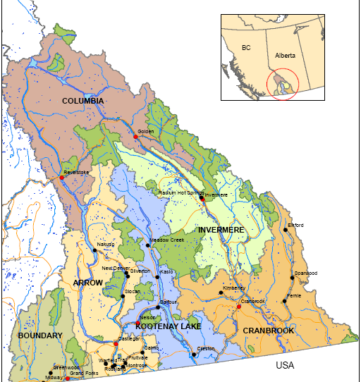

CONTACT INFORMATION
General Inquiries:
Southeast Fire Centre
Phone (250) 365-4040 Fax (250) 365-9925
208 Hughes Road
Castlegar, BC
V1N 4M5

Boundary Fire Zone
Office: 236-570-2094 ZWCO: 236-570-2094
Fax: 250-442-0350

Mail Address: Boundary Fire Zone
BC Wildfire Service
120 60th Avenue
Grand Forks, BC, V0H 1H4

Staff Call Sign Cell Home

James Katasonoff, Wildfire Officer SE 60 250-442-7082 250-442-7082
james.katasonoff@gov.bc.ca

Roxanne Keil, Operations Assistant SE 68 250-444-9234 250-447-9234
roxanne.keil@gov.bc.ca

James Ritco, Wildfire Technician SE 61 250-442-7361 250-442-0867
james.ritco@gov.bc.ca

Dylan Turmel, Wildfire Technician SE 62 250-442-9715 250-613-6177
dylan.turmel @gov.bc.ca

Kelsey Sask, Wildfire Assistant SE 63 250-443-1540 250-819-0321
kelsey.sask@gov.bc.ca

Ryan Gow, Wildfire Assistant SE 64 250-814-8481 250-814-7202
ryan.gow@gov.bc.ca

Timothy Palek,Crew Supervisor SE 67 250-442-7369 250-447-9591
timothy.palek@gov.bc.ca

Stan Webb, Fire Crew Leader SE 610A 250-442-7422 250-300-1964
Stan.Webb@gov.bc.ca

Ian Nagel, Fire Crew Leader SE 620A 250-443-9186 250-442-7436
ian.nagel@gov.bc.ca

Jacob Grandbois, Fire Crew Leader SE 630A 250-444-9757 365-400-5168
jacob.grandbois@gov.bc.ca

Bailey Shaw, Fire Crew Leader SE 640A 250-442-7395 250-449-5250
bailey.shaw @gov.bc.ca

PLEASE NOTE;

grand forks airport east gate combination padlock is 4013#

and you have to push down on the top part of the padlock once the code is input to pop the top up. make sure to lock it in the same manner upon departure.

ATTACK BASES

The Grand Forks Attack Base including the Zone office is located at the northeast area of the Grand Forks Airport.

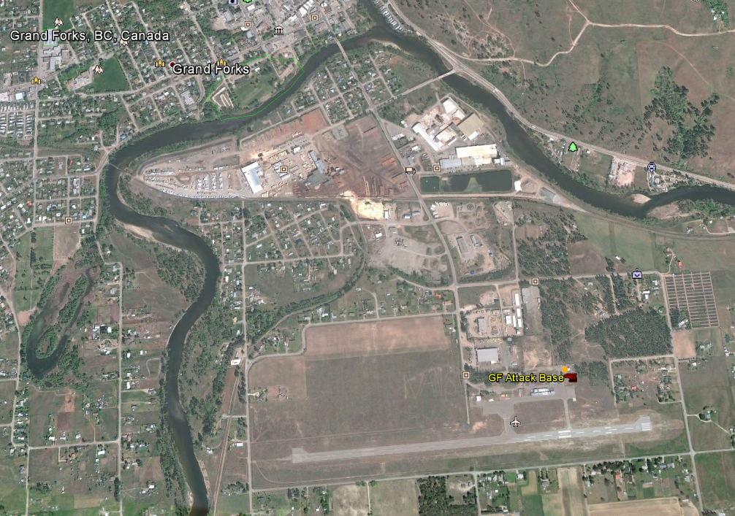
Grand Forks Attack Base – 5980 2nd Street, Grand Forks, BC.
Lat/Long: 49 01.062 N 118 25.528 W

A forward attack base is located at Kettle Valley east of Rock Creek. It is about 5 km east of

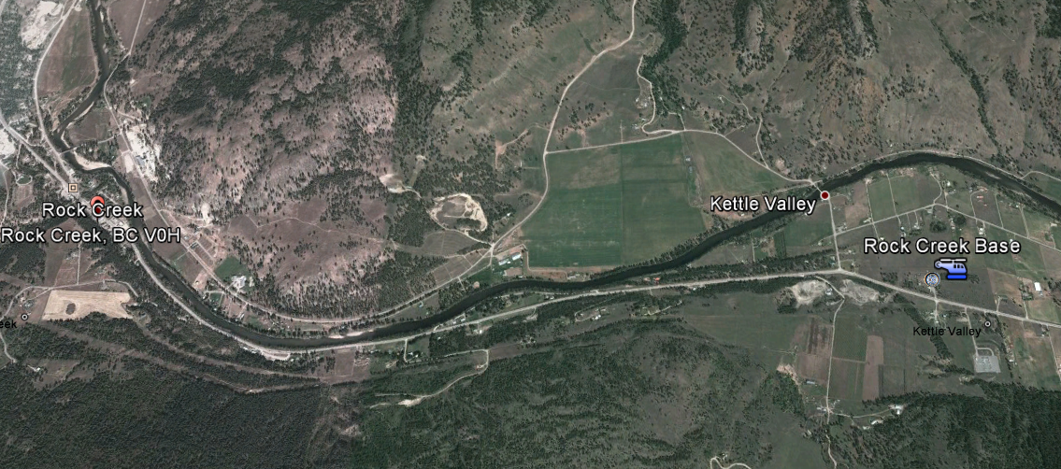
Rock Creek. Lat/Long: 49 3.142 N 118 56.194 W

GEOGRAPHY

The Zone includes the communities of Christina Lake, Grand Forks, Greenwood, Midway, Rock Creek, Bridesville, Mt. Baldy, Beaverdell, and Carmi with the Village of Big White residing just north of our boundary within the Penticton Zone. The Boundary Zone is within the Selkirk Resource District.
The Zone consists of three major north-south valleys. The main valleys are the West Kettle River, Kettle River, and the Granby River.

The Monashee Mountain Range within the Zone includes the Kettle River Range in the east and Okanagan Highlands in the west. Mountains generally range from 1500 m to 2400 m ASL.
Grand Forks is one of the lowest elevations being 525 m ASL.

The Zone is intersected by 2 main highways. Highway 3 traverses from west to east along the southern portion of the area. Highway 33 commences at Rock Creek traveling northwest to Kelowna.

CLIMATE

The Boundary Fire Zone is within the interior dry belt. While this is indicative of the overall dryness in the valleys, the northern areas of the Zone are generally cooler and wetter.

Prevailing wind direction is southwest. Generally winds are light to moderate, but we have seen damaging winds from convective build-ups.

Convective lightning storms tend to arrive from either the south or west. Storms from the west will generally take a path to the northeast. Fire starts in the west and north portions of the zone are most common. When lightning storms approach from the south they can generally be wetter, but can start a number of fires in our southern areas which are drier. The lighting prone areas are Rock Creek, Beaverdell, North Granby and Christina Lake.

FUELS

Main forest species in the area include; Ponderosa Pine, Lodgepole Pine, Douglas-Fir, Western Larch, Western Red Cedar, Western Hemlock, Engelmann Spruce, Subalpine fir, Trembling Aspen, and Paper Birch.

The Canadian Forest Fire Behavior Prediction System fuel types in the Boundary Fire Zone are generally C-3, C-4, C-5, C-6, C-7, S-1 and O-1a/b.

HAZARDS

Watch out:

- Downburst winds associated with convective cells can be severe
- Scattered Mountain Pine Beetle infested stands
- Poison ivy is common
- Rattlesnake habitat in the south, however very few interactions have been reported
- Black widow and brown recluse spiders are common highly poisonous insects. They tend to inhabit areas where it is dark, cool, and moist.
- Poison Control Centre - 1-800-567-8911 for snake bites or spider bites.
- Ticks are present in the area and most prevalent in the spring.
- Dehydration and Heat Stress during hot, dry weather which is common.

Please refer to information provided in the Appendices regarding, snakes, spiders, ticks, dehydration and heat stress.

CAUTIONS

- Few motels available in the west; Greenwood is best for room availability.
- No vehicle fuel north of Rock Creek on Hwy 33. Red Rock Garage in Beaverdell does accept ARI cards.
- Don’t fuel up at Mobil in Grand Forks – they don’t accept the ARI card.
- Poor cell phone service outside of communities.
- Local business hours are very short.

Hospitals

Boundary Hospital (stabilize, wound care and ship)
7649 – 22nd Street, Grand Forks BC
Phone: (250) 443-2100
Phone ER w/injury type & ETA for ambulance or helicopter.

Grand Forks Airport: 49 01.006 N 118 25.727 W

Hospital Helipad: 49 01.840 N 118 28.184 W
Single or twin engine helicopters

Kootenay Boundary Regional Hospital (Major Trauma)
1200 Hospital Bench, Trail BC
Phone (250) 368-3311

Hospital Helipad: 49 06.216 N 117 42.019 W (TWIN ENGINE R/W)
or
Land at Trail Airport and meet BC Ambulance; 8995 Highway 22A;
(250)-367-0029
Trail Airport: 49 03.404 N 117 36.485 W

KELOWNA General Hospital (Major Trauma)
2268 Pandosy Street, Kelowna BC V1Y 1T2
Phone: 250 862-4000 Then press “0”
Airport 49° 52.458 119 29.550

Hospital Helipad: Restricted to twin engine of less than 18 m length heli (212 or smaller)
Airport 49° 52.433 119 29.587

Note special helipad procedures as follows:
If BC Wildfire Service is transporting a critical injury into Kelowna General Hospital by air call BC Ambulance at 911 BC Ambulance Dispatch with coordinate staff to meet the incoming patient with BC Ambulance Heliport Dispatch and the hospital.

An alternate procedure would be to meet BC Ambulance at the Alpine Helicopters base at West Kelowna. A phone call to Alpine must be made to confirm there is staff present to prepare the helipad and unlock the facility for BC Ambulance

Main Alpine number: 250-769-4111
Operations Manager: Sam Chivers 250-769-5151 (Home Number)

Consider Penticton as an alternate for less serious injuries.
PENTICTON Regional Hospital

550 Carmi Avenue, Penticton BC, V2A 3G6 (No helipad at the hospital, only the airport)
Airport 49° 27.783 - 119° 36.100
Hospital Phone: 250 492-4000 Then press “0”

Plan to meet BC Ambulance at the airport for incoming air transport. Notify Penticton Zone staff who may be available meet BC Ambulance and coordinate a smooth delivery to BC Ambulance from our aircraft. Penticton Zone Main Number: 250-770-3700

OLIVER South Okanagan General Hospital
7139-362 Ave, Oliver, BC, V0H 1T0

Airport 49° 10.441 N 119° 33.074 W
Helipad (Field beside hospital) 49 10.976 N 119 32.405 W

Hospital Phone: 250 498-5000 (local 5010 for the Emergency Room)
If transporting by air consider Penticton as a better alternative for more serious injuries. There is a field adjacent to the hospital to land or the Oliver Airport strip is only 2.5 km from the hospital to meet BC Ambulance.

VALUES at RISK

- Potential interface areas: Christina Lake, Grand Forks Rural area, Greenwood, Midway, Rock Creek, Westbridge, Christian Valley, Beaverdell, and the Ski Resorts of Mt. Baldy and Big White (with Big White Village centre being in the Penticton Fire Zone.)

- Significant Client assets include 500 kv hydro ROW owned by BC Hydro; Fortis Electrical wood pole infrastructure & Fortis Gas ROW. A large microwave facility is located at 24 kilometer on the Santa Rosa Rd and there are several other radio repeaters and cell towers. The Telus fiber-optic cable network is a high valued asset as well.

- A large portion of the Zone is within the Timber Harvesting Land Base. Timber is a very important resource to the local economy. The Boundary TSA is rated as High within RSWAP.

The Arrow-Boundary Fire Management Plan is located at: https://www.for.gov.bc.ca/ftp/!Project/Fire_Management_Planning/CurrentYear_FMP/FireCentre/SouthEast/N6/FireManagementPlan_Document/

US/Canada Border

Boundary Zone shares an international Border with the USA. It is important to maintain constant communications with the SEFC with any regard to staff crossing the Border. The Contacts and Protocols are detailed in the SEFC Pre-Org Manual. The key requirements are appropriate personnel manifest, employees carry passports, and a truck inventory list. An agreement exists to allow each country to take initial attack on any fire that threatens forest land along the border.

If air operations are taking place near the border advise the pilots to utilize the
SQUAWK CODE: 1255 unless another specific code has been designated by the FAA.

A Cross Border Checklist is included as an Appendix to the Briefing Package and needs to be carried by all Fire Crews and Officers.

LOOKOUTS

There is one Lookout located in the Boundary Zone. This lookout is no longer staffed but remains as a strategic point of interest for fire response resources:

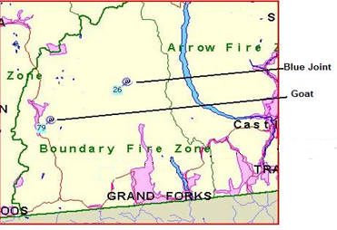
GOAT LOOKOUT – Phone 250-442-7414
Location: 49 24.835 N 119 0.914 W

At a height of 5712 feet, Goat Lookout oversees a vast area of both private and crown land in the West Kettle and Christian Valleys. This Lookout oversees the communities of Beaverdell and Carmi and an area identified by our assessment process as an extreme interface fire hazard area. It can see the south and east facing slopes of the Big White Ski resort, as well as numerous lakes and recreation sites where there is high recreational use. Much of the area it oversees is contained within Interfor’s TFL8 and the core harvesting area of their forest licence.
This Lookout is manned with the observer traveling to and from Beaverdell.

EQUIPMENT CACHES:

Geographic | Lats/Longs | Remarks
Grand Forks Fire Attack Base | 49° 01.061’ x 118° 25.529’ | CACHE  Full Level 3 FA stretcher kit
Kettle Valley Forward Attack Base  5 kilometres east of Rock Creek on north side of Hwy 3 – key is stashed | 49° 03.121’ x 118° 56.214’ | CACHE  Heliport  Full Level 3 FA stretcher kit
Beaverdell Air Strip  2 kilometres north of Beaverdell on west side of Hwy 33– key is stashed | 49° 27.387’ x 119° 05.318’ | CACHE  Heliport  Full Level 3 FA stretcher kit

FUEL CACHES:

The Zone manages 4 fuel caches of drummed fuel in very limited quantities. The locations are noted in the table below. The City of Grand Forks has a 19,000 tank of jet fuel at the Grand Forks airport which is a self-use dispensing unit accepting credit card payment.

Please update the drum fuel counts with the ZWCO when fuel is used.

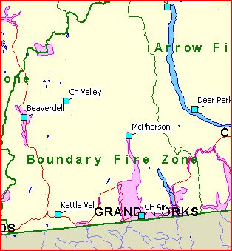

 | Fuel Cache | Latitude/Longitude | Remarks
 |  |  | JET A
 | Grand Forks Airport  ZGF Grand Forks | 49° 01.010 N x -118° 25.762 W | City Bowser  19,000 L
 | Granby  40.5 km on the North Fork Road  Inside range fence to West | 49° 20.535 N x -118° 27.503 W | 2 barrels min
 | Christian Valley  44.5 km on the Christina Valley main and 150 m to east inside hay compound | 49° 30.732 N x -118° 49.488 W | 2 barrels min
 | Rock Creek Base  5.5 kilometres east of Rock Creek on north side of Hwy 3 | 49° 03.129 N x -118° 56.156 W | 4 barrels min
 | Beaverdell Airstrip  2 kilometres north of Beaverdell on west side of Hwy 3 | 49° 27.201 N x -119° 05.217 W | 2 barrels min

WEATHER STATIONS

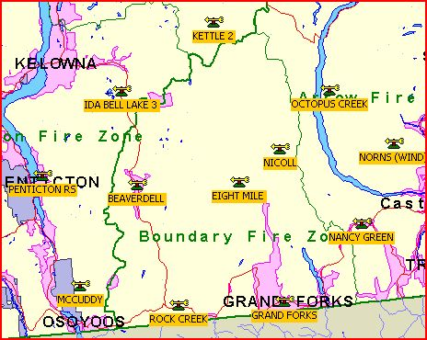

Eight Mile and Nicoll provide upper elevation indices. Beaverdell, Rock Creek and Grand Forks are located in valley bottoms. See the map in the Zone Fire Control Room for the representative areas covered by each station.

FIRE WARDENS

Randal Smith Mt. Baldy 60 Charlie
250-498-2183 Home 250-498-7765 Cell

Flo Hewer-Beaverdell 60 Foxtrot
250-484-5658 Home 250-212-3936 Cell

Mike Hooge-Grand Forks 60 Hotel
250-442-9898 Cell Only

Doreen McGrath – Beaverdell 60 Juliet
250-484-5335 Home 250-878-2853 Cell

Heinz Kreuzer – Midway 60 Kilo
250-449-2657 Home 250-449-8448 Cell

Kelly Harpur – Rock Creek 60 Mike
250-446-2416 Home 250-443-5941 Cell

Gary Maletta-Greenwood 60 Whiskey
250-445-6478 or Cell 250-444-0051

Pre-Org Manual

The SEFC and Zone Pre-Org Manuals are electronic compilation of information. We use MS Office OneNote software for the pre-org manuals.

They are located at: G:\!Publish\PreOrg.

If required the Zone staff can help you get them loaded onto your computer.
Boundary Zone has completed Equipment Rental Agreements and Equipment Rate Sheets loaded onto the Southeast Fire Centre SharePoint Site as well.

APPENDICIES

BRIEFING CHECKLIST

Ensure that you get a proper INCOMING briefing that includes:

- A Copy of Your Manifest is received and passed on to SEFC
- Your number of Duty days is recorded and passed on to SEFC
- Your Contact Numbers and Call Sign is recorded and passed on to SEFC
- Radio Use
- Check-Ins
- Current and Forecasted Weather
- Current Indices
- Fire Behaviour Warnings/Advisories
- Current Fire Situation
- Red Book Fuel Types in the Zone
- Fire Numbering System (N6000 etc)
- Fire Report/Paperwork Requirements
- Pre-Org documents – phone numbers; Contacts; Equipment Lists
- Crew Rotation
- Standby procedures/Preparedness, Mins, Mods, Max
- Your Assignment
- Start Times
- Requirement for 8-Hour Break (Clear 8)
- Taking Overnight Gear When Dispatched
- Use of Contract Crews
- Local Hazards/Wildlife Concerns
- Local Industry contacts, (Interfor/Weyerhaeuser)
- Field Safety Plan
- Location of First Aid Equipment
- Grand Forks Fire Base Orientation (Grounds/Buildings/keys/Security)
- Local Topography
- Forward Attack Base and equipment cache locations
- Fuel cache locations
- Fire Wardens, Lookouts, Support staff
- Grand Forks Fire Base Orientation (Grounds/Buildings/keys/Security)

Arrival Briefing Form

Date: In Attendance: Time: Location: ____________

Location, cause, size, potential, values, priorities, status (i.e. out of control, contained etc. attach map showing fire boundaries, guards, crew locations, pumping sites, heavy equipment, helispots and other pertinent info).

Fire Priority in Zone:

Area Strategy and Suppression Objectives:

Fire Management Team Reporting Relationship (include existing fire organization/attach org chart Fire Management Team)

Conference calls
    - WX Mondays and Thursdays, 0915 PST
    - Daily WX briefings
    - IC to OPS/RWCO _
    - Other

Agency Representatives:
BC Wildfire___________________________________________________________________
Company:____________________________________________________________________
Private Land agreement:
Parks
First Nations:__________________________________________________________________
Other:_______________________________________________________________________
____________________________________________________________________________
Delegations of Authority (establish protocol and identify individuals responsible for functions between the incident and Fire Centre, i.e. logistics)

Issues (i.e. Forest Operations, Reserves and Outfitters, Fire Cause Investigation ‘Arson’)

Safety (watchouts:, animals, mines, road cdx etc)

Political and Media:

Evacuation Guidelines (includes structural fire fighting)

Base Camp(s)/Accommodation

Special Services Available (IR, Wx, Tech)

Burning Out Guidelines

Notam

Communications Systems (Comm Tech.)

Wx (current weather indices and forecasts) Hand out current wx information

Resources on Fire:
A/C_________________________________________________________________________Manpower____________________________________________________________________
Equipment ___________________________________________________________________
Other________________________________________________________________________

Back-up Resources Immediately Available:

Resource Requisitioning Procedures (A/C, manpower, equipment and fuel)
A/C:
Personnel:
Heavy equipment:
Equipment :
Cptr/phones/etc:
Other (specify):

Information Requirements and Time Frames

- IAP and/or updates due at SEFC Plans 0700 daily. fax to 250-365-8519

Priorities / Objectives for Fire Management Team Members:

Short Term (next 72 hrs refer to functions checklists)

Incident Commander Assignment Representative

Name: Name:

Signature: Signature:

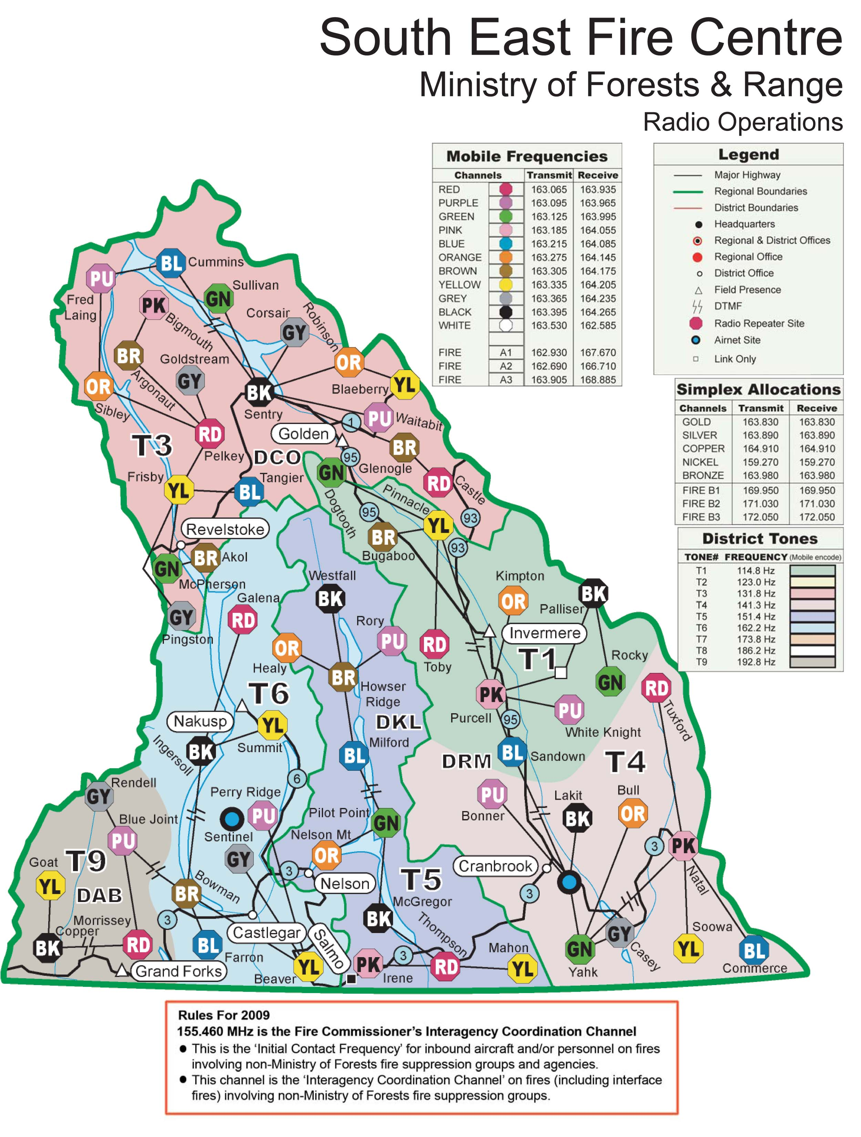

2015 Repeater Map in PDF Format: https://www.for.gov.bc.ca/ftp/!Project/RadioOperations/RadioRepSites/Wildfire%20Management%20Maps/2014/Large/

RATTLE SNAKES

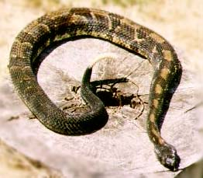

Northern Pacific Rattlesnake

While working in the Boundary Zone, it is important to understand that you are within the habitat of the Northern Pacific Rattlesnake (NPR). The only species of rattlesnake found in B.C., it is also the only truly venomous snake species in our province. They range in areas from Merritt North to Alexis Creek, South throughout the Okanagan, and East to Christina Lake. In the Boundary, the NPR is typically found on dry South-facing slopes such as those found in the areas of Grand Forks and Midway.

The NPR is a stout snake, distinguished from all other B.C. snakes by 3 features; a rattle on the end of its tail, a very distinct neck, and a broad, triangular head. Even their faces are unique – rattlesnakes have large eyes with vertical pupils, a long, dark cheek patch, and they have deep pits between their nostrils and their eyes that contain heat-sensing cells. Most rattlesnakes are greenish in color with brown outlined yellowish circles on their backs. Rattlesnakes share similar colouration and body characteristics with several other snake species, the most common being the Gopher Snake and the Western Terrestrial (Wandering) Garter Snake. However, neither of these species have a rattle, nor do they have vertical pupils.

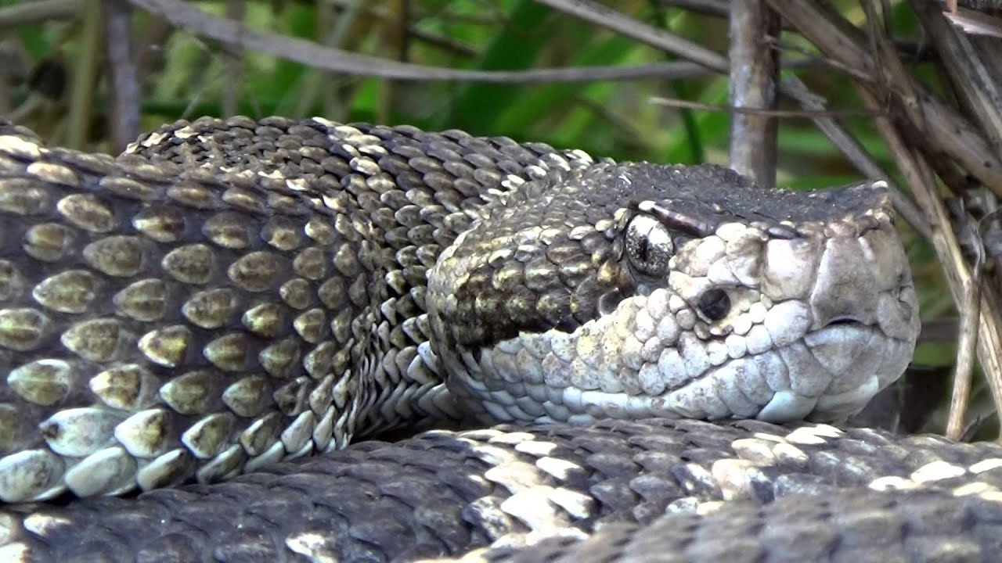

The NPR is generally a quiet, non-aggressive snake. Their first response to potential danger is to stay still and camouflaged. Their second response is escape. If cornered however, rattlesnakes will rattle their tails vigorously while forming an aggressive coil with the head raised and the neck in an ‘s’ shaped curve. Striking is a last resort, usually employed if cornered by a persistent predator or occasionally when stepped on.

Rattle Snake Bites

Prevention is the best cure for many injuries, and this is certainly true in the case of snakebites. Bites from rattlesnakes are extremely painful and may in rare cases be fatal. Rattlesnakes should be avoided if possible, however If you encounter a rattlesnake, slowly back away from it and warn others in the area. If disturbing rocky habitat, bang your Pulaski or shovel on rocks prior to flipping them over and always wear leather gloves. Do not reach into long grasses or under rocks without disturbing the area first. If you encounter a dead rattlesnake, do not attempt to touch it as the biting reflex remains intact even after death.

If you or a co-worker are bitten;

- Remain calm and remove yourself and others from the immediate area. Remember; death from an NPR strike is extremely uncommon.
- Remove any constrictive clothing or jewelry which may prevent blood flow to the strike area.
- Loosely immobilize limb with a splint and keep below the heart level.
- Gently clean around the wound as this may prevent infection.
- Mark the swelling around the wound with lines and times every 10 minutes as this can assist medical staff with accessing the wounds severity
- Immediately transport the patient to the nearest healthcare facility.

DO NOT;

- Do not apply ice; use of ice has been associated with increased incidence of amputation.
- Do not use a tourniquet or constrictive band as it is difficult to apply with the proper pressure; this might lead to Venom concentration which can increase tissue damage.
- Do not incise fang marks and suck venom from the strike area; this is totally ineffective and can damage tissue and contaminate wound.
- Do not use oral suction or extraction devices for the same reasons listed above.

The Boundary Hospital in Grand Forks carries a supply of rattlesnake antivenom as do all the hospitals in the greater Okanogan area. The optimal timeframe for transport of a bite patient is 45 min to 1 hour from one of these hospitals. This is generally enough time to begin management of an NPR bite without further complications. The only time someone may need faster transport is if they are having an allergic reaction to the venom. In this case the victim would be exhibiting signs of an allergic reaction such as difficulty breathing, swelling in throat, etc. This is very uncommon. In 25% of cases, adult NPR bites are a “dry bite” in which the snake strikes but doesn’t inject venom. Baby rattlesnakes usually always inject venom.

The NPR is protected under the Wildlife Act and as such, it is illegal to kill, maim, or otherwise remove them from the wild. Doctors do not need to identify snakes prior to treatment of a patient as the NPR is the only rattlesnake species present in the Province.

Ticks and Humans in British Columbia
There are more than 20 species of ticks in British Columbia, but only three species normally bite humans. Although the bites may sometimes be painful and slow healing, there is little danger of disease provided they are removed promptly. Adult ticks are distinguished from insects by having eight legs rather than six. They cannot jump or fly and do not drop from trees. Ticks require blood as a source of protein for egg development. A few simple precautions outlined below, will decrease the likelihood of tick bites.

The Rocky Mountain Wood Tick (Dermacentor andersoni)
In British Columbia, this tick occurs in the interior dry belt from the United States border north as far as Williams Lake and eastward into Alberta. It is not found west of the Coast Range mountains. The Rocky Mountain wood tick is a three-host tick, a new host being sought for each one of its three feedings which occur over a period of 1 to 3 years. Usually rodents and other small animals serve for the first two feedings, and large animals such as deer, cattle, dogs, sheep and humans serve as the host for the last feeding. This tick is most frequently encountered between March and June, usually in open, rocky areas.
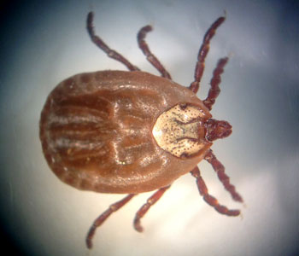 | Rocky mountain wood tick female

The adult female is reddish-brown with a white "shield" near the front, and the similarly sized male is mottled-grey in colour. Both sexes "quest" for hosts by waiting near the top of grass and low shrubs, readily attaching to passing humans or animals that brush against them. Once on a host they climb upwards, giving rise to the erroneous observation that they have dropped from trees. If the quest is unsuccessful, the ticks return to the ground until the next spring. Ticks successful in finding a host attach their mouthparts to the skin by means of a rapidly hardening cement. Feeding females quickly increase in size, excreting a mass of black bloodwaste during the process. When they reach the size of a swollen raisin they drop to the ground and, after several weeks, lays a few thousand eggs and dies.
Although the Rocky Mountain wood tick is a known carrier of Rocky Mountain spotted fever, tularemia, and Colorado tick fever in the United States, these diseases rarely occur in Canada. However, in British Columbia this tick causes a disease in man and animals called tick paralysis.
The disease is characterized by increasing lack of coordination and eventual collapse. The first symptoms, usually a numbness in the feet and legs causing difficulty in walking and standing, occur after a female tick has been feeding for about 5 days. The hands and arms are usually affected next and there is often partial paralysis of the throat and tongue muscles, resulting in difficulty swallowing and speaking. There is little pain and usually no fever. Complete recovery occurs when the tick is removed if paralysis has not progressed too far, but death may occur if the tick is overlooked. There is no known antidote for tick paralysis. The nature of the toxin, likely secreted by the female during feeding, is not known.
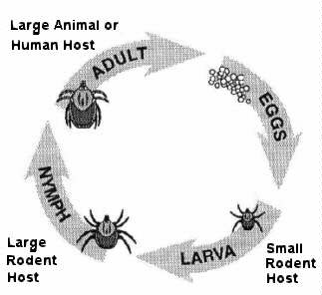 | Life Cycle of Dermacentor andersoni

The Western Black-legged Tick (Ixodes pacificus)
The Western Black-legged tick is very common during the spring and early summer. It occurs on vegetation in warm, moist areas on Vancouver Island, the Gulf Islands, and along the mainland coast between the United States border and Powell River. Its eastward range extends along the Fraser River to Yale and north to Boston Bar.
The red and black females and smaller black males attach to humans, deer, cats and dogs, becoming grey and bean-like in size as they feed. The bite is often painful and may result in a slow-healing ulcer. This tick does not cause paralysis; however, it is a carrier of the microorganism responsible for Lyme disease in North America. The organism which causes Lyme Disease, Borrelia burgdorferi, has been found in ticks collected from many areas of B.C., and health authorities now believe that Lyme Disease carrying ticks may be present throughout the province. For more information on Lyme Disease, see the B.C. Centre for Disease Control web site.
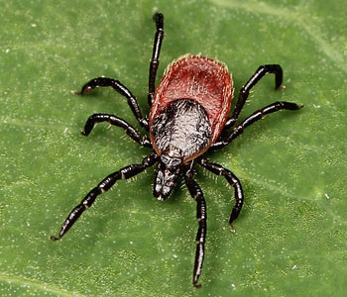 | Western black-legged tick (Ixodes pacificus)  Photo: Creative Commons, by Ryan Kaldari, licensed under CC0 1.0

Other Ticks
Many other British Columbia ticks feed only on a narrow range of hosts such as squirrels, rabbits, groundhogs and birds. Probably the one most commonly encountered by man is the winter tick. It feeds on moose, deer, horses and cattle during the winter but, while it may brush off onto humans, it will not feed on man.
The brown dog tick is a reddish-brown species that attacks dogs, usually feeding around the ears and between the toes. It rarely feeds on humans. This species may be found around cracks and baseboards in homes after dropping off a dog.

Removal of Attached Ticks
Many methods have been developed over the years for removing feeding ticks which connect themselves to their host with small, barbed mouthparts. Ticks do not burrow under the skin. A number of the more drastic techniques such as using a hot cigarette, gasoline, or hot matches to induce the tick to detach itself are unreliable and may cause injury to the person involved. Ticks are most safely and effectively removed by a slow and gentle pull without twisting, using tweezers or fingers. This will normally remove the tick with the mouthparts attached. The wound should be treated with an antiseptic. See the BC Center for Disease control web site for further information on removal of ticks.

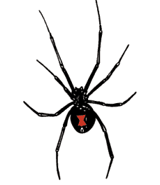

POISINOUS SPIDERS

BLACK WIDOW – This poisonous spider has long gangly legs, is gross black in colour with a red hour glass on the underside of its oversized abdomen. Some of these spiders reach sizes of over 5 cm in length from leg tips to leg tips. It resides in the dry interior and likes dark areas.
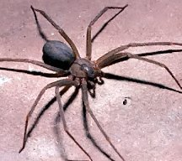
BROWN RECLUSE – This poisonous spider is a shiny light brown and is smaller than the Black Widow. The Recluse has an identifying black fiddle on the underside of its abdomen.

If bitten by either spider, get the person to hospital immediately for treatment.

Personal Protection
The following precautions will decrease the likelihood of tick attachment.
- Wear high boots or tuck pant cuffs into socks. Tuck shirt into pants. Do not wear short pants. Application of commercial insect repellents containing diethyl toluamide (DEET) to the pants may assist in repelling ticks.
- If possible, avoid game trails or old roads overgrown or closely lined with vegetation. Tick levels may be high in areas frequented by animals.
- When resting, sit on a bare rock, a ground sheet, or a vegetation-free area instead of stretching out on vegetation.
- Make daily examinations for ticks, paying particular attention to the pubic region, the base of the skull, and the scalp. Check the backs of everyone in the group and carefully inspect any children. Clothes should be closely examined for ticks, especially near the collar, after they have been hanging overnight.
If you have the following symptoms within days or weeks after being bitten by a tick, please report them to your family doctor immediately. Tell your doctor when and where you were bitten by a tick. If possible, keep any removed ticks and take them to your doctor who may need to have the ticks identified. Ticks can be stored in any sealed container in a fridge or freezer.
- General symptoms of fever headache, muscle and joint pains, fatigue or weakness of the muscles of the face.
- Skin rash, especially one that looks like a "Bull's Eye". It may or may not be where the bite was.
- In some cases paralysis may occur. The paralysis usually starts in the feet and legs and gradually works its way up to the upper body, arms and head. This paralysis can develop from within a few hours to several days.

